**NAME- DEVANSHU SURANA**

**ELECTIVE ROLL NO-BT1-18**

**PANEL ROLL NO- PC-23**

**PRN-1032210755**

**PANEL-C**

**Assignment 2**

**Install MetaMask Cryptocurrency Client in Chrome as Extension and demonstrate currency transfer operations using Sepolia Test Network**

**1). Aim:** To install MetaMask cryptocurrency client in Chrome as an extension and demonstrate currency transfer operations using Sepolia Test Network

**2). Objectives:**

* Install MetaMask Cryptocurrency Client Extension on Google Chrome.
* Demonstrate currency transfer operations using the Robsten Test Network.
* Verify successful execution of cryptocurrency transactions within the MetaMask environment.

**3). Theory:**

Testnets :

**4). Implementation :**

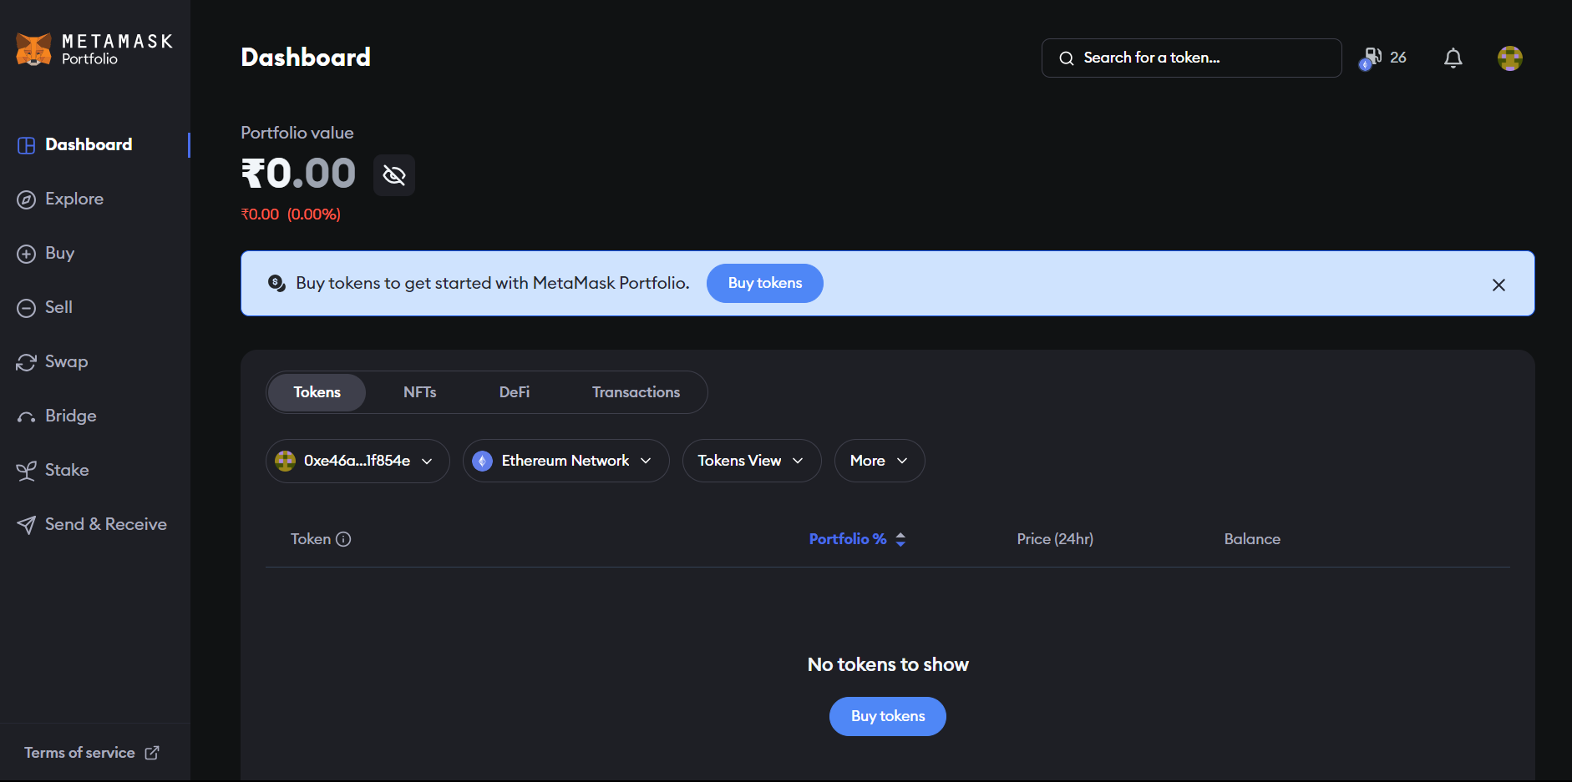

2.1). MetaMask user dashboard

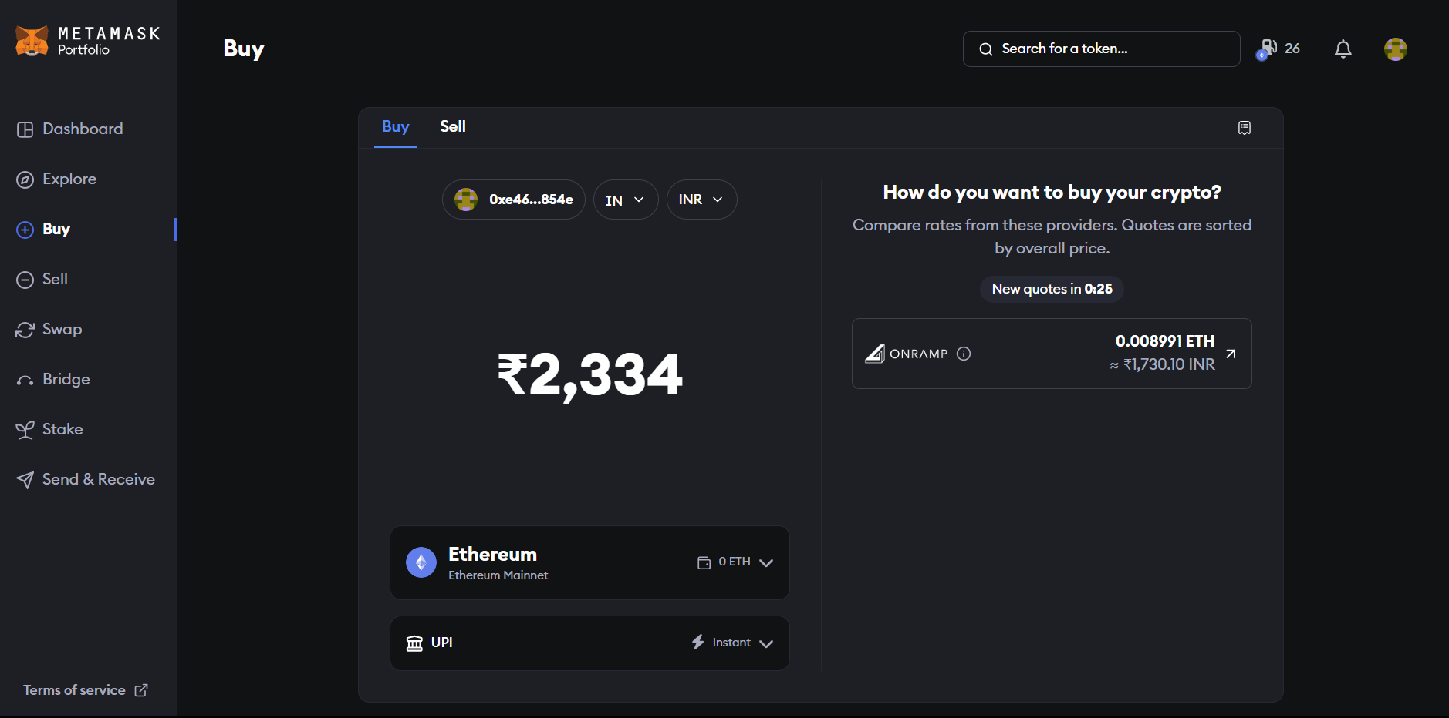

2.2). MetaMask’s ‘Buy’ page

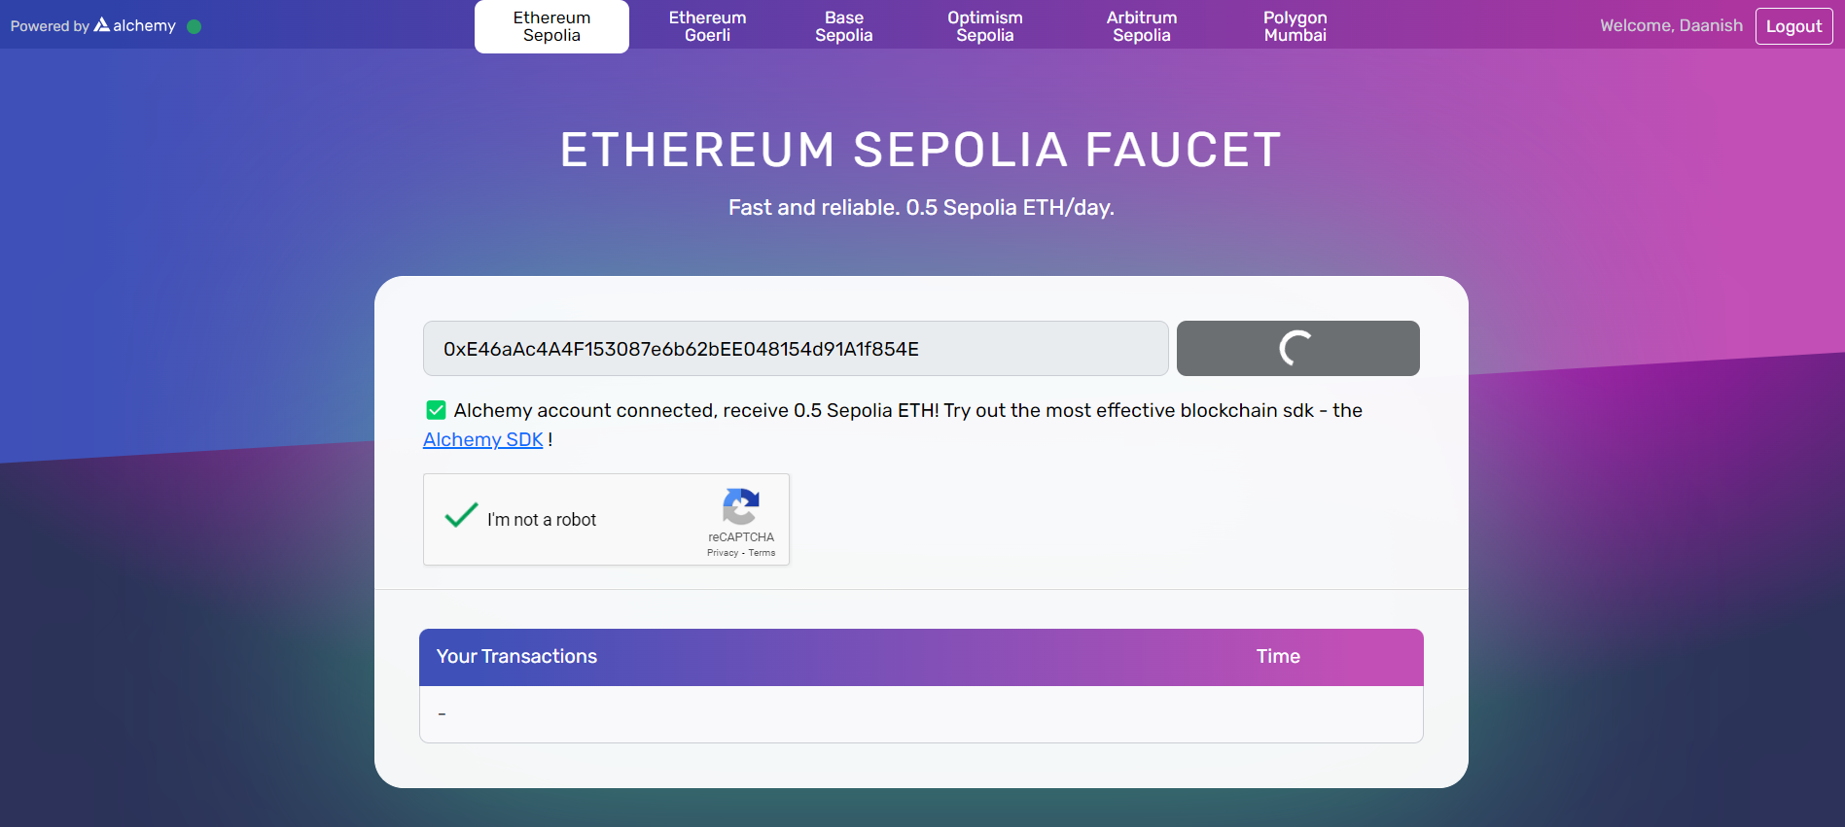

2.3). Sepolia transaction in process

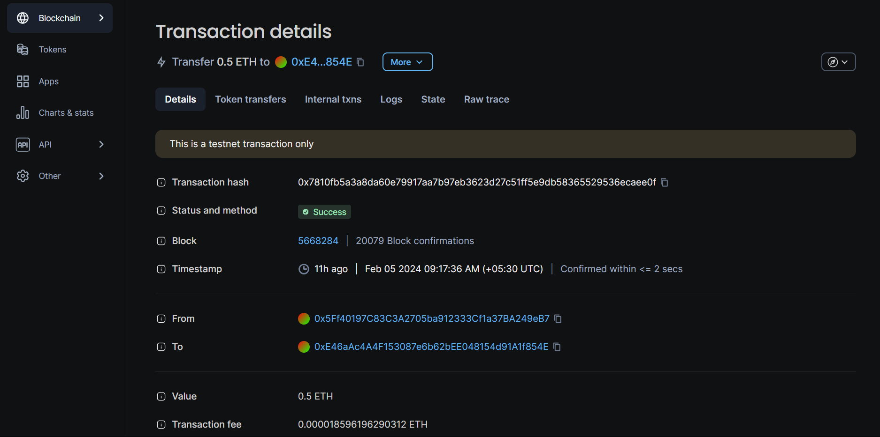

2.4). Successful transaction message prompt for Sepolia

**5). FAQs :**

1. What steps are involved in installing MetaMask as a Chrome extension and connecting it to Sepolia Test Network?

* Install MetaMask Extension:
* Open the Chrome Web Store in your Chrome browser.
* Search for "MetaMask" in the search bar.
* Click on the "Add to Chrome" button next to the MetaMask extension.
* A pop-up will appear; click "Add Extension" to confirm the installation.
* Once installed, the MetaMask icon will appear in the upper-right corner of your browser.
* Configure MetaMask:
* Click on the MetaMask icon to open the extension.
* Set up a new MetaMask wallet or import an existing one.
* Follow the on-screen instructions to create a secure password.
* Save the generated seed phrase in a secure location.
* Complete the setup process.
* Connect to Sepolia Test Network:
* Open MetaMask and click on the network selection (Ethereum Mainnet).
* Choose "Custom RPC" and enter the details for the Sepolia Test Network.
* Network Name: Sepolia
* New RPC URL: https://sepolia.infura.io/v3/YOUR_INFURA_API_KEY
* Chain ID: Custom
* Symbol: ETH
* Block Explorer: https://sepolia.etherscan.io/
* Save the configuration and connect to the Sepolia Test Network.

1. What are the key features of MetaMask in facilitating currency transfer operations?

* The key features of MetaMask in facilitating currency transfer operations include:
* User-Friendly Interface: MetaMask provides an intuitive and user-friendly interface, making it accessible for both beginners and experienced users.
* Wallet Management: It serves as a digital wallet, allowing users to manage multiple cryptocurrencies, including Ether (ETH), and providing a secure storage solution.
* Browser Extension: MetaMask operates as a browser extension, seamlessly integrating with popular browsers like Chrome. This extension enables users to interact with decentralized applications (DApps) directly from their browsers.
* Currency Transfer: MetaMask facilitates secure and efficient currency transfer operations. Users can send and receive cryptocurrencies easily within the MetaMask wallet.
* Support for Test Networks: It supports various test networks, such as the Robsten Test Network, allowing users to test currency transfer operations without using real assets.
* Smart Contract Interaction: MetaMask enables interaction with smart contracts on the Ethereum blockchain, providing a gateway for users to engage with decentralized applications and execute transactions based on predefined conditions.
* Security Features: MetaMask incorporates robust security features, including encrypted private keys and password protection, ensuring the safety of users' digital assets.
* Network Customization: Users can customize their network preferences, including selecting different Ethereum networks or adding custom networks, enhancing flexibility in currency transfers.
* In summary, MetaMask's key features encompass a user-friendly interface, wallet management, browser extension capabilities, efficient currency transfer operations, support for test networks, smart contract interaction, security measures, and network customization options.

1. Can you describe the significance of using a test network like Sepolia in this demonstration?

* The use of a test network like Sepolia holds significant importance in this demonstration. It provides a controlled environment for conducting currency transfer operations without affecting the Ethereum mainnet. Developers can experiment with test Ether and tokens, ensuring the functionality and security of their smart contracts before deploying them in the live network. Sepolia's faster block confirmation times and reduced congestion contribute to a smoother testing experience, allowing developers to identify and address issues effectively. This ensures a robust and reliable implementation when transitioning to the Ethereum mainnet.

1. In what ways does the Sepolia Test Network differ from the Ethereum mainnet in this context?

* Sepolia Test Network differs from the Ethereum mainnet as it serves as a testing environment for developers.
* It involves transactions with test Ether and tokens, holding no real-world value. Sepolia operates independently, ensuring actions on the test network don't impact the Ethereum mainnet.
* With faster block confirmation times, availability of test tokens, and reduced congestion, Sepolia offers a controlled space for developers to experiment before deploying on the live Ethereum network.

**6). Conclusion :**   
In summary, installing MetaMask on Chrome and demonstrating currency transfers on the Sepolia Test Network offered practical insights into blockchain operations and test network functionalities.